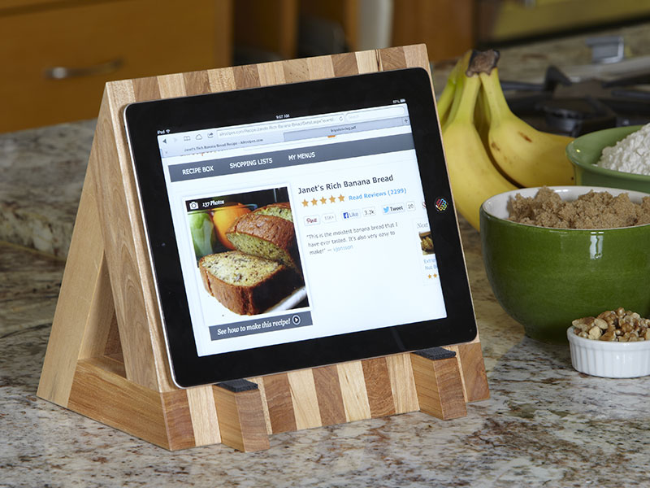

Book stand/ Tablet Holder (code-DETH1)

Cookbooks in the kitchen, thrillers on the nightstand, reference books in
the library—this handsome book stand handles them all, even marking your
place without damaging the spine. Or, if your household is a little more
high-tech, a simple modification turns it into an iPad stand.

- Dimensions: 16 H x 16 W x 16 D (inches)
- Colour: Natural pine wood colour
- Assembly: No Assembly Required
- Primary Material: Solid Wood

Home Decoratives
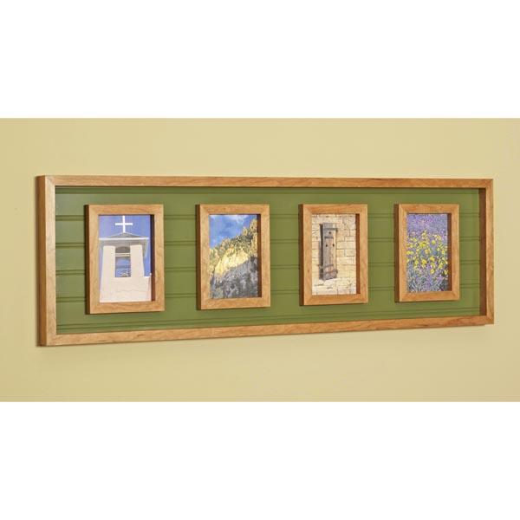Multi Wood Photo Frame (code:DEMWPF1)
Coordinate with your color scheme, pull together your pictures, and showcase your shop skills. All in a single frame. Not only is this frame fetching, itâ€™s also flexible. Need more photo than the four spaces? Add a few parts and stretch a couple measurements. Or shrink it as needed.

- Dimensions: 16 H x 26 L x 3 W ( inches)
- Colour: Customised
- Assembly: No Assembly Required
- Primary Material: Pine wood
- Room Type: Living Room
- Code: DEMWPF1

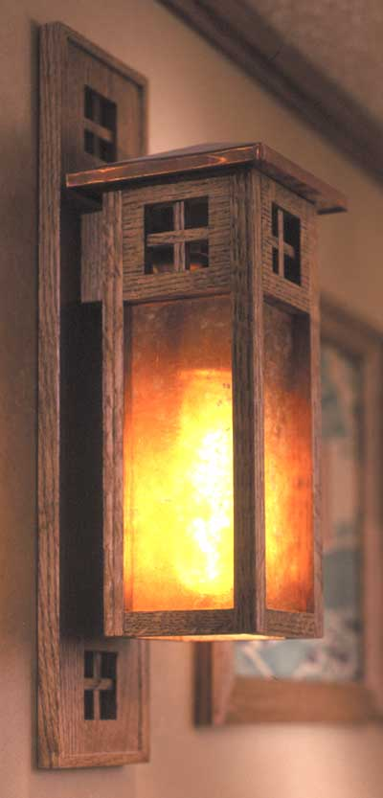

Wall Sconce (code-DEWS1)

The warm, golden glow of an incandescent lightbulb shining through a
sheet-mica diffuser is a hallmark of Arts and Crafts lighting. Add this
ambience to your home with one or more of these oak and copper wall-mounted
sconces.
Measures approximately 9-1/2" inches tall.
- Dimensions: 9 1/2 H x 6 W (inches)
- Colour: Honey Dark
- Assembly: No Assembly Required
- Primary Material: Rubber Wood
- Room Type: Living Room
- Code: DEWS1

Luminous Dispaly Pedestal ( code-DELDP)
Woodworkers talk about finishing wood to make the grain glow, but when you turn on the light inside this display table, the grain literally shines as the quilted-maple-veneer panels come to light. By day it's a display table with clean simple lines. It really shines after dark, though.
Overall Dimensions: 17" wide by 17" deep by 41" high. (inches)
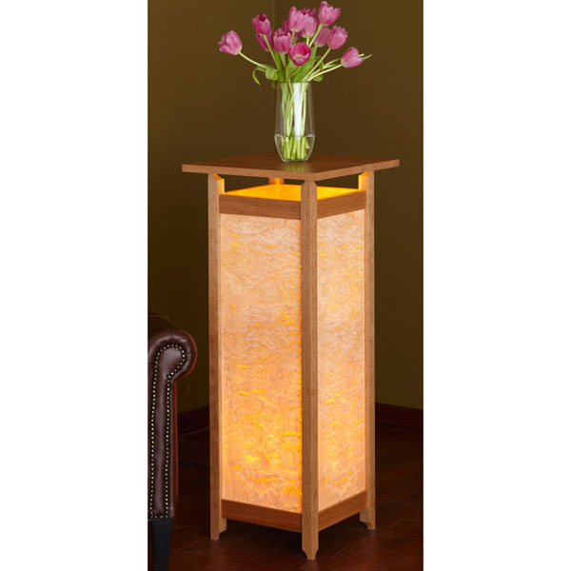

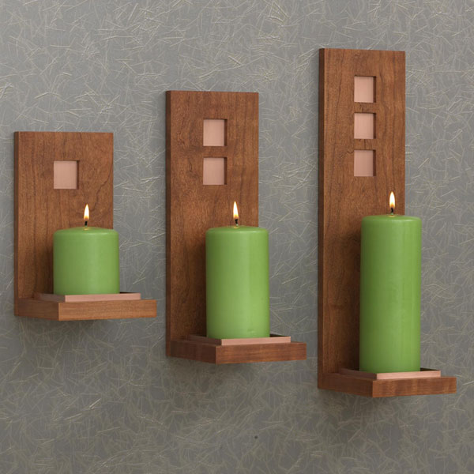wall Sconces – 2 (DEWS2)
Add ambiance to any room with these candleholders, made from cherry and accented with copper tray liners and back inserts..
- Dimensions: 10 H x 5 L x 1 thickness (inches)
- Colour: Honey Dark
- Assembly: No Assembly Required
- Primary Material: Pine Solid Wood
- Room Type: Living Room

